Software Requirements Specification
For
<Monitoring and Evaluation System for ICCR’s Regional Offices (ROs)>
Version 1.0 approved
Prepared by <author>
<organization>
<date created>
Table of Contents
Table of Contents ii
Revision History ii
1. Introduction 1
1.1 Purpose 1
1.2 Document Conventions 1
1.3 Intended Audience and Reading Suggestions 1
1.4 Product Scope 1
1.5 References 1
2. Overall Description 2
2.1 Product Perspective 2
2.2 Product Functions 2
2.3 User Classes and Characteristics 2
2.4 Operating Environment 2
2.5 Design and Implementation Constraints 2
2.6 User Documentation 2
2.7 Assumptions and Dependencies 3
3. External Interface Requirements 3
3.1 User Interfaces 3
3.2 Hardware Interfaces 3
3.3 Software Interfaces 3
3.4 Communications Interfaces 3
4. System Features 4
4.1 System Feature 1 4
4.2 System Feature 2 (and so on) 4
5. Other Nonfunctional Requirements 4
5.1 Performance Requirements 4
5.2 Safety Requirements 5
5.3 Security Requirements 5
5.4 Software Quality Attributes 5
5.5 Business Rules 5
6. Other Requirements 5
Appendix A: Glossary 5
Appendix B: Analysis Models 5
Appendix C: To Be Determined List 6

Revision History
Name | Date | Reason For Changes | Version

Introduction

Purpose
ICCR main objective is to monitor all its Regional Offices (ROs) in India on real-time basis for all the activities they conduct, which would ultimately help ICCR to implement its activities effectively and efficiently and thus, evaluate their performances on real-time basis.

Document Conventions

Intended Audience and Reading Suggestions
The intended audience who will be mainly using our system are:
ICCR, ROs, Institutes and Students.
- ICCR is the primary stakeholder with a separate dashboard to manage Regional Offices and evaluate their activities.
- RO’s will be provided with a dashboard to schedule activities, upload reports for the activities conducted and manage students and handle their grievances.
- Institutes will be provided funds by the ICCR to conduct cultural events at the institute level.
- Students can give feedback of the events conducted in their institutes.

Product Scope
Monitoring and evaluating all activities of ICCR’s Regional Offices and evaluate their performances on real-time basis.
- Look after the interest of foreign students studying in various states of India.
- Keep track of Monetary Information spent on students and other establishment expenditure.
- Develop mechanism to coordinate with local cultural and educational organizations and the State Government for carrying out ICCR’s based activities.

References
- Indian Council for Cultural Relations, Wikipedia, https://en.wikipedia.org/wiki/Indian_Council_for_Cultural_Relations#Publications, Oct 3,2022
- Official website of Indian Council for Cultural Relations, Government of India, https://iccr.gov.in/about-us, Oct 3,2022
- ICCR Annual Report: Indian Council for Cultural Relations Azad Bhawan, I.P. Estate, New Delhi, 2020-21

Overall Description

Product Perspective
It is a web portal with separate dashboards for each stakeholder ICCR, ROs, Institutes and Students whose main objective is to monitor and evaluate the cultural activities in the institutes and provide them with funds and special performance ratings for conducting ICCR events.
At the same time making the Indian students aware about Indian cultures as well as the foreign students by proving them with scholarships to study our culture in India.
Its objectives are to actively participate in the formulation and implementation of policies and programmes pertaining to India's external cultural relations, to foster and strengthen cultural relations and mutual understanding between India and other countries and to promote cultural exchanges with other countries

Product Functions
Main Functionalities of this portal are:
- Facility of generating the monthly activity report based on activities conducts or events organized at the institute level.
- Generating feedback form links for sharing it amongst participants of events to collect their review and feedback of the events organized to better perform next time.
- Rating mechanism is one of the unique functions of the designed system.

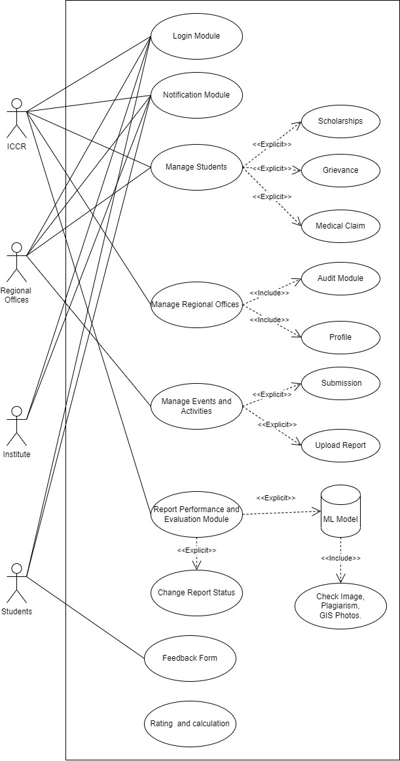
User Classes and Characteristics

Operating Environment
Our website can smoothly work on both windows and mac-os operating systems.

Design and Implementation Constraints
Since the entire website is in only one language i.e English it might be difficult for other people speaking different languages.

Assumptions and Dependencies
It is already assumed that all the stakeholders ICCR, ROs, Institutes and Students are already registered on the web portal.
Internet connectivity and OS like Windows or Mac-OS can some of the dependencies.

External Interface Requirements

User Interfaces

Communications Interfaces
Communication channel between all the stockholders for effective running of the system.
Through communication channels the ICCR monitor the activities of the ROs , the ROs can evaluate the institutes to conduct cultural events and the students and review the events through feedback mechanisms about the events and cultural activities conducted in their institutes.

System Features
The section illustrates the functional requirements for the product and the major services provided by the product.

Functional Requirement

REQ-1: Login for the stakeholder:
All the stakeholder will separate login.

REQ-2: Stakeholder will be provided with separate dashboard.

REQ-3: Monitoring and Evaluation of reports:
All the monthly reports provided by the RO will be helpful to monitor whether the activities are properly conducted or not and would be evaluated by the ICCR.

REQ-4: Rating mechanism:
The RO and institutes will get ratings after evaluation of the reports.

REQ-5: Evaluation by RO:
- The RO would evaluate the report submitted by the institutions and provide funds to conduct more of such activities.
- RO will get all the details of the activity conducted in the report.

REQ-6: Student module:
  - Student will get all relevant information of upcoming activities.
  - Student can also get information of previous activities.
  - Applications for scholarship would be made available to the students.
  - Feedback form for the activity would be provided.

Other Nonfunctional Requirements

Performance Requirements
- The report uploaded by the Institution or RO should not be larger than 50 MB.
- Smooth working of website is must to ensure good user experience.
- Server will be working 24X7.

Safety Requirements
- Access to unauthorized student would be prevented.
- Student will not be a part in making or editing activity report.
- No one other than RO and ICCR would have access to institute reports.

Security Requirements
- Access to unauthorized student would be prevented, same for the Institute as well.
- Student should be enrolled in the institute to fill the feedback form and apply for scholarship.
- Only authorized student would be able to apply for scholarship and fill the feedback.
- Only ICCR would have access to monitor and evaluate the monthly activity reports of RO.

Software Quality Attributes
- Map is an additional feature that provide information of RO’s in India.
- The System is easy to maintain.

Other Requirements
Appendix A: Glossary
ICCR: Indian Council for Cultural Relations.
RO: Regional offices.
Activity: Events, work determined by ICCR.

Appendix B: Analysis Models

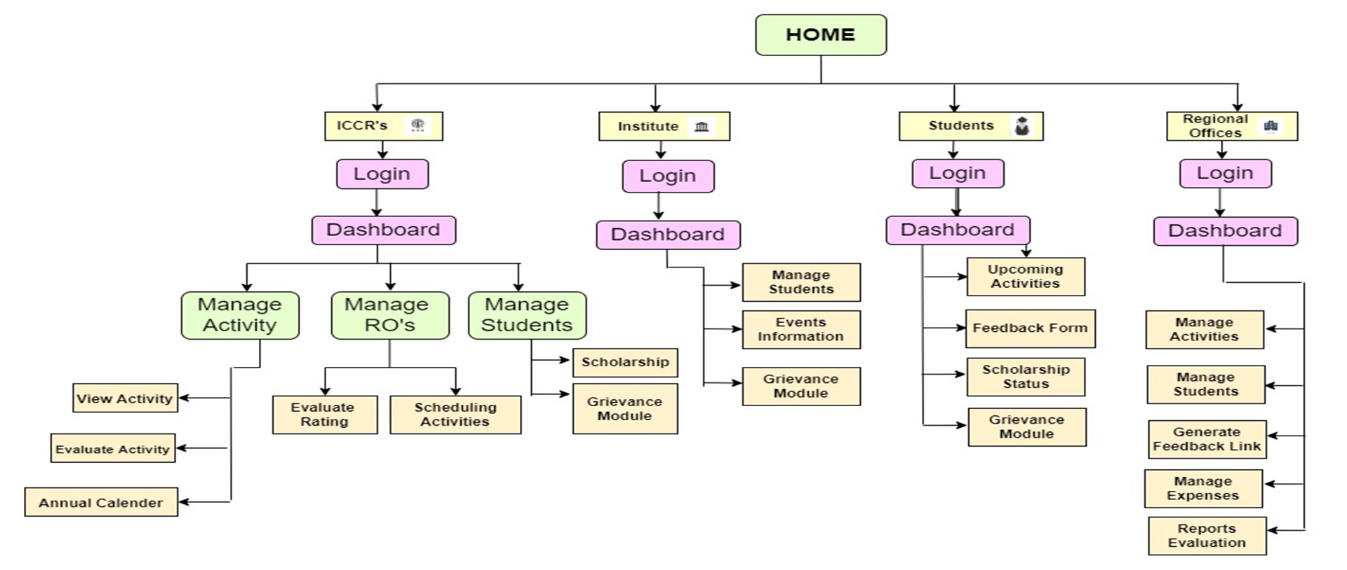
Appendix C: To Be Determined List
<Collect a numbered list of the TBD (to be determined) references that remain in the SRS so they can be tracked to closure.>

